**February 17th-21st**

Dear Parents,

|  |
| --- |
| **Words to practice** |
| needle |
| between |
| feature |
| increase |
| extreme |
| complete |
| meter |
| secret |

Here is our word study pattern this week:

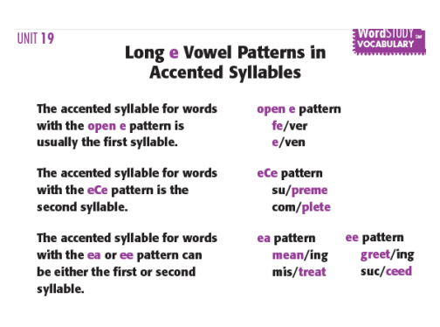

Students should complete the homework sheet stapled to this sheet and practice the words above for this skill. In addition, each student has 5 high frequency words to learn taken from their individualized lists for the spelling test on Friday. They will need to write down their high frequency words and write their sentence.

**Reminder:** On our Jackson Third Grade website page, there are additional word cards and category cards to practice this pattern. <http://www.shakopee.k12.mn.us/Page/2454>

|  |  |
| --- | --- |
| **High Frequency Words** | **These are my weekly high frequency words used in a sentence.** |
|  |  |
|  |  |
|  |  |
|  |  |
|  |  |